**Manuals for ‘Manage Booked Appointment’**

**Brief of the ‘Manage Booked Appointment’ –** This is the page where we can see the appointment details of patients with respective doctor.

**1. How to manage booked Appointment-.**

Steps:

1. Login to the site and go to ‘Masters’ tab and click on ‘Manage Booked Appointment’.
2. On ‘Manage Booked Appointment’ page there is doctor name dropdown and search button.
3. Select the doctor name and click on search button, all the appointment will display with respective doctor name.

1.

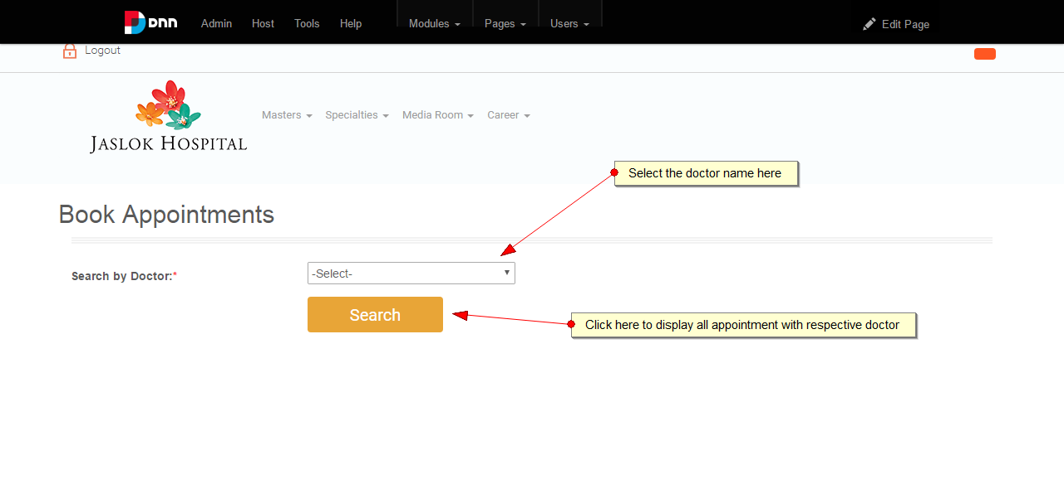

2.

